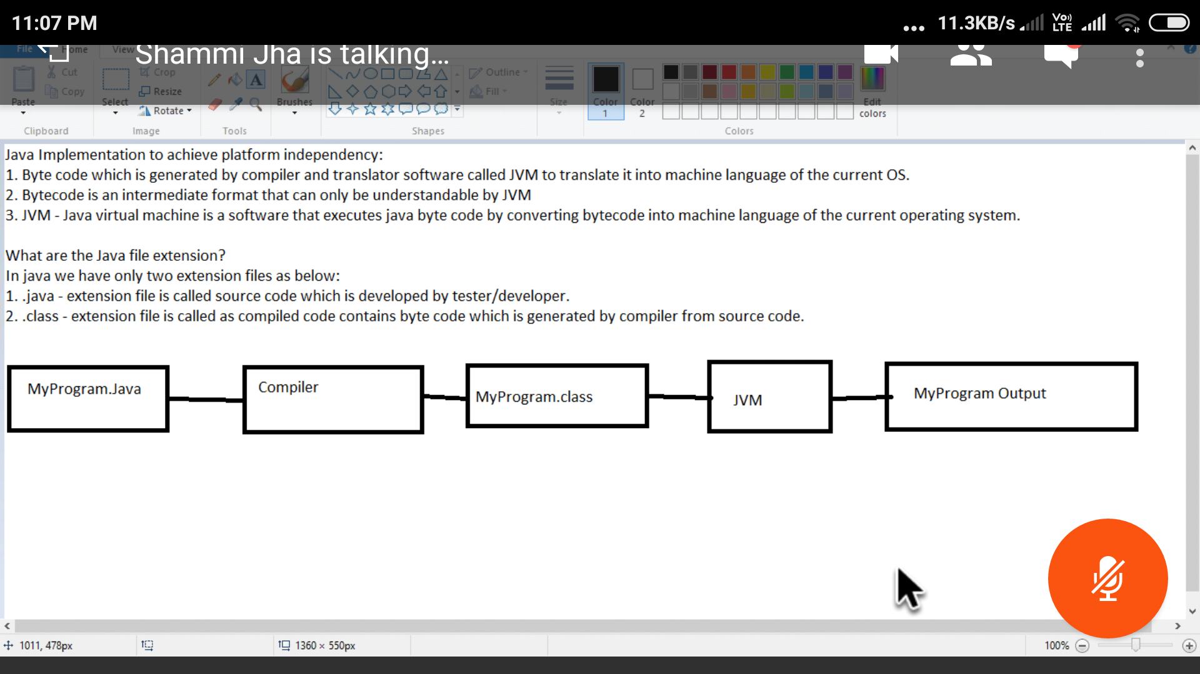

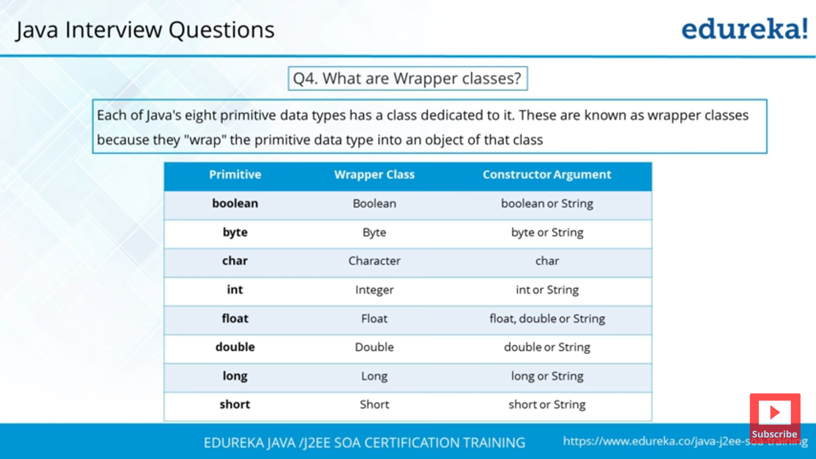

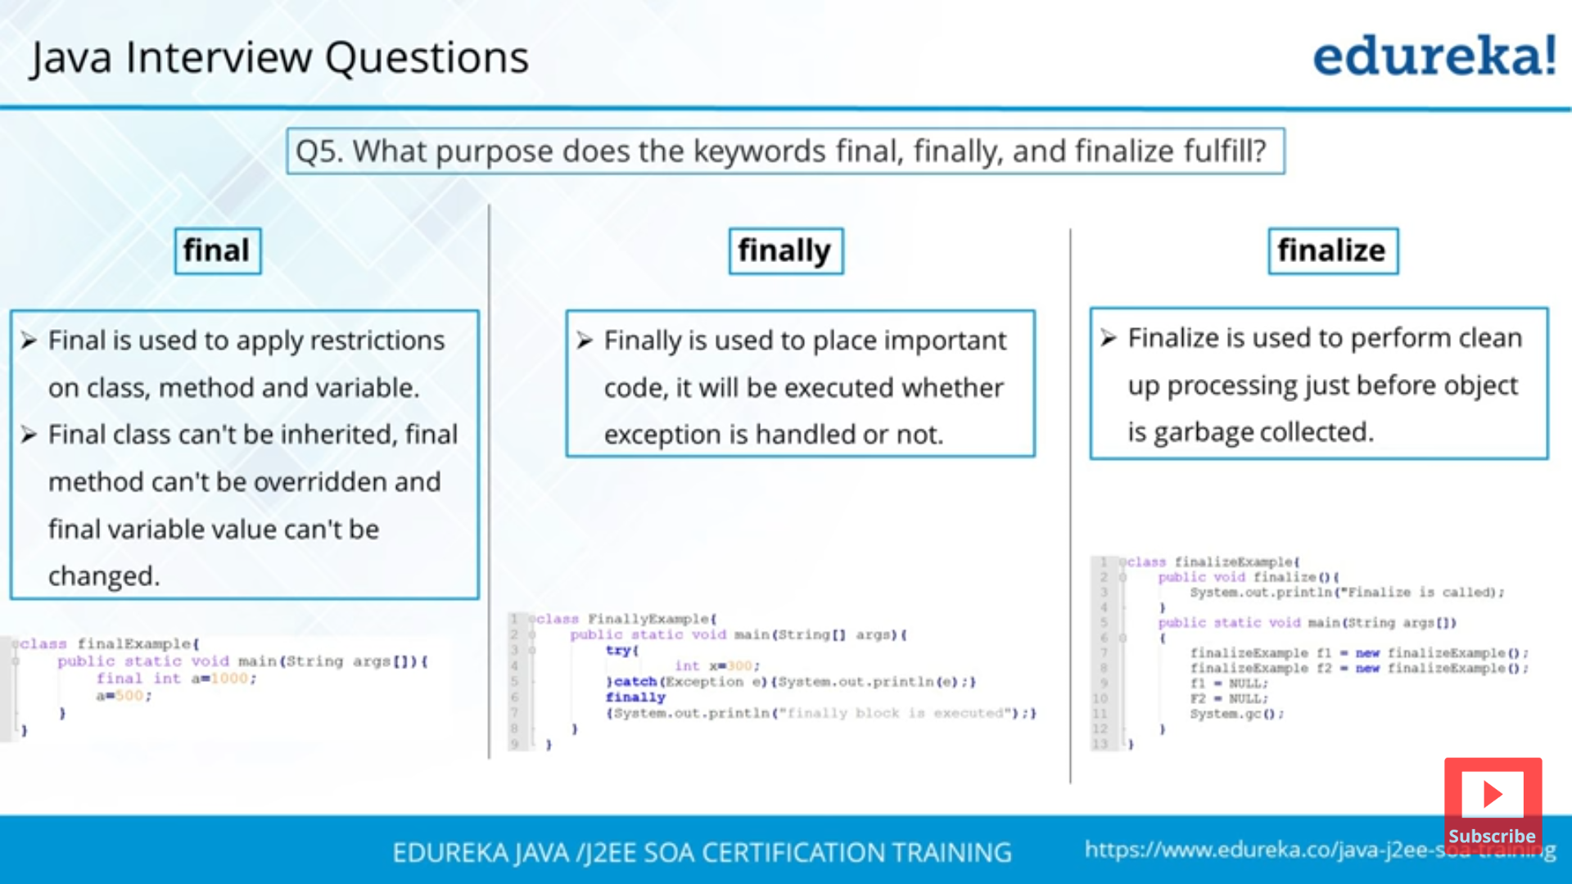

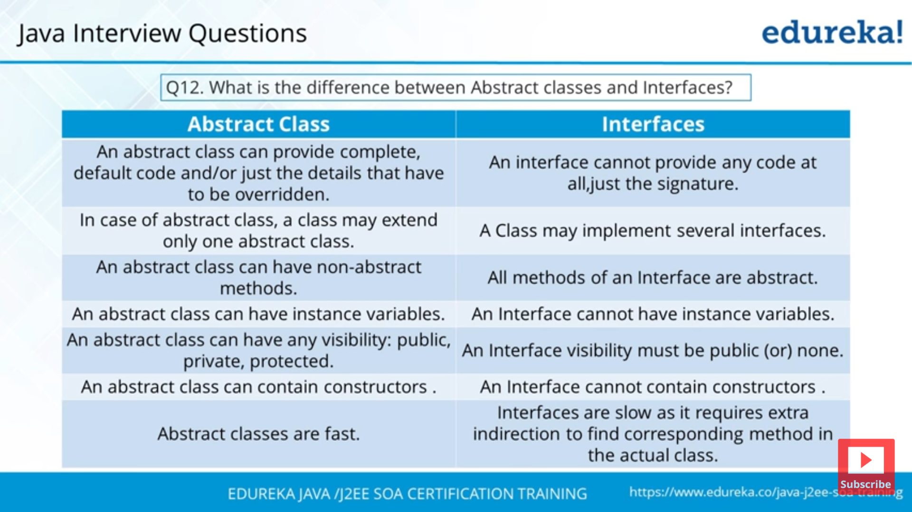

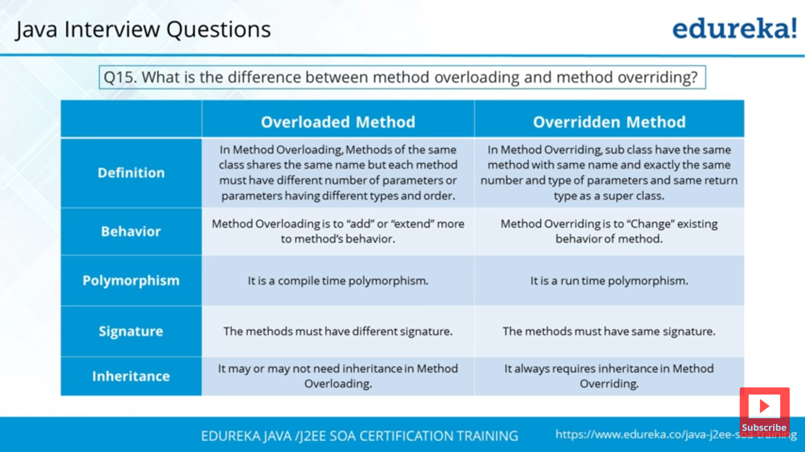

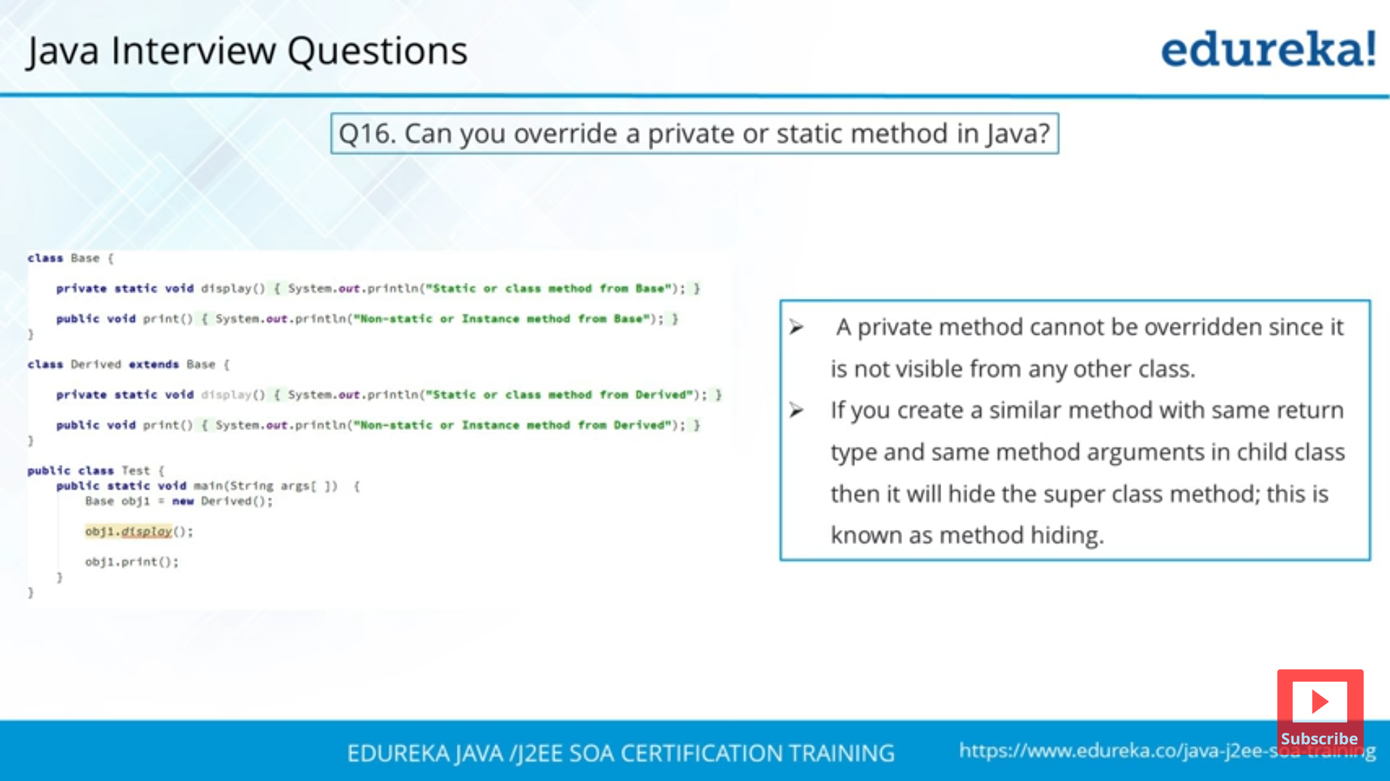

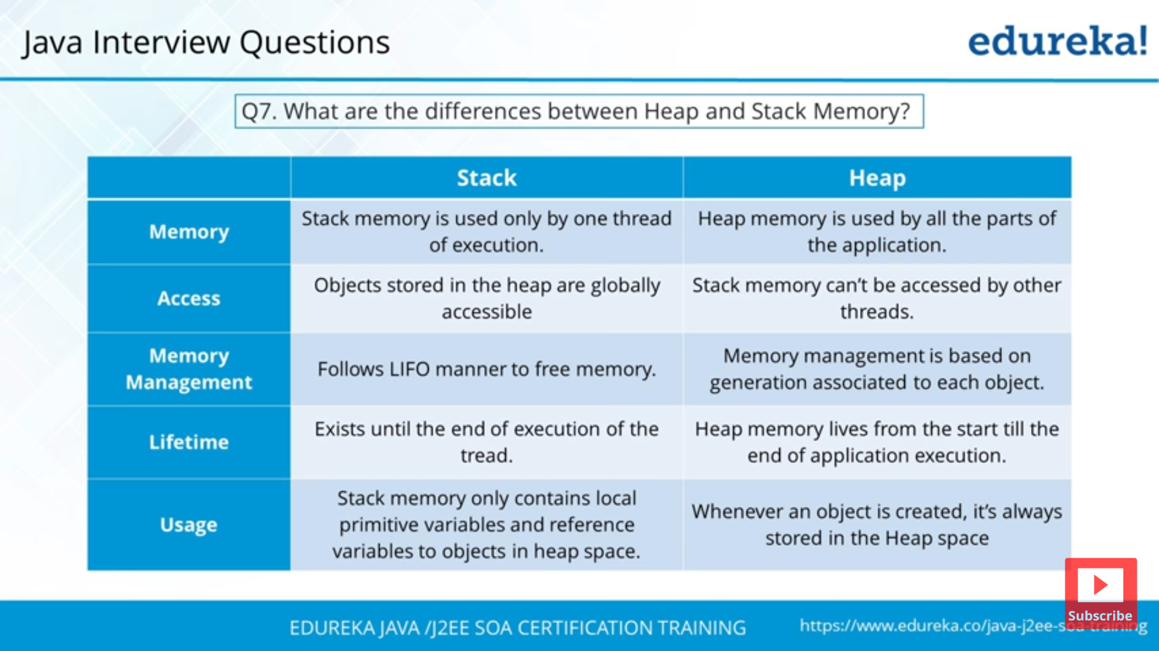

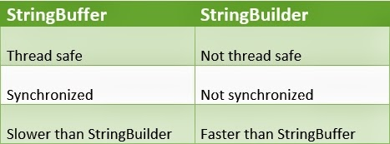

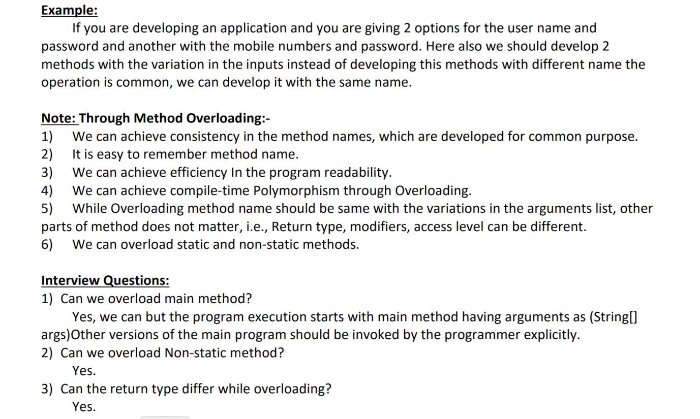

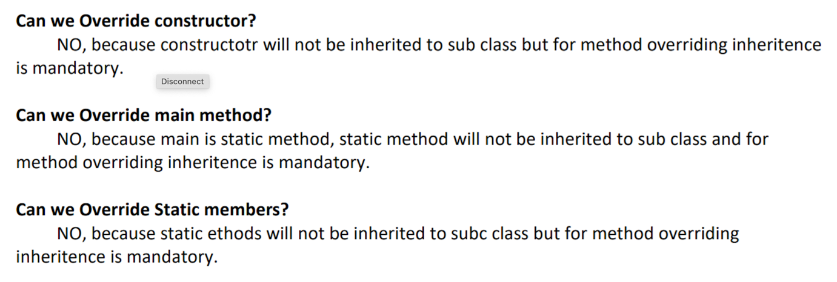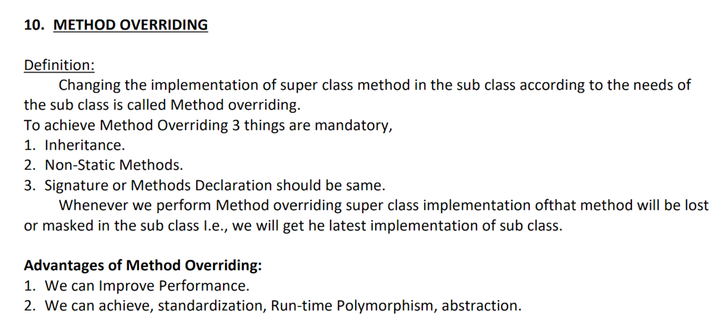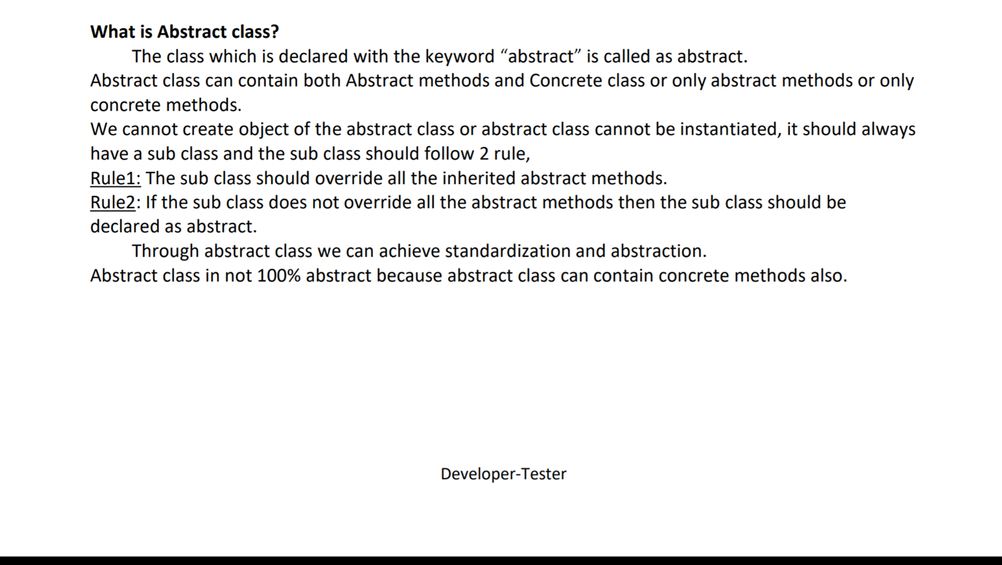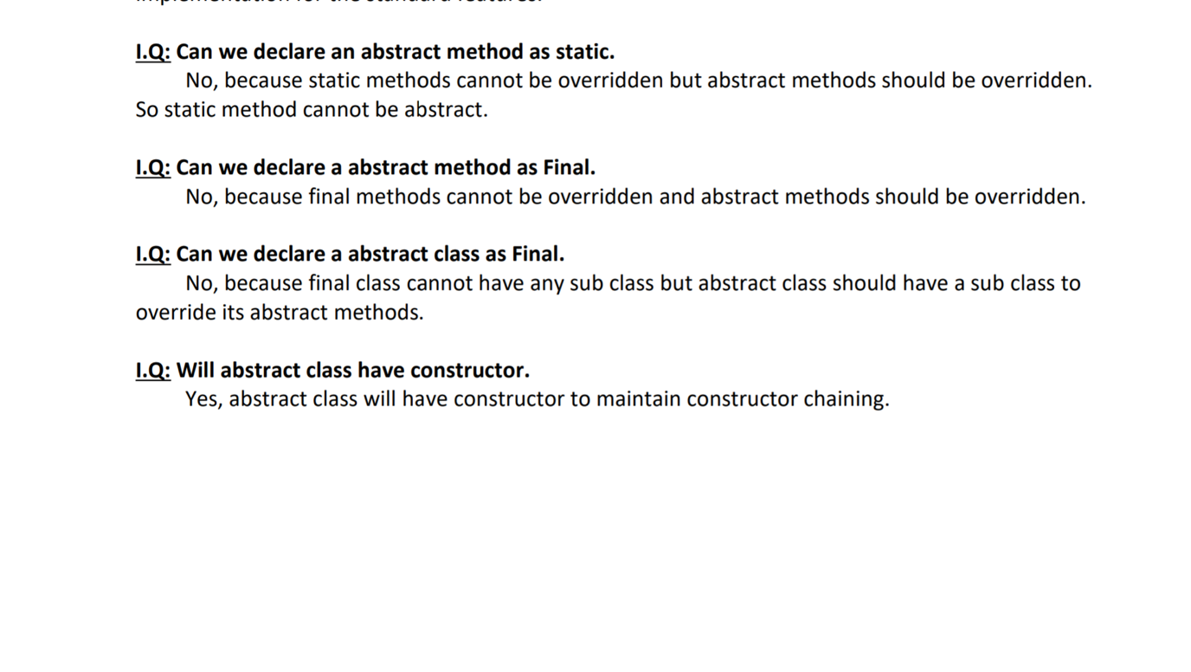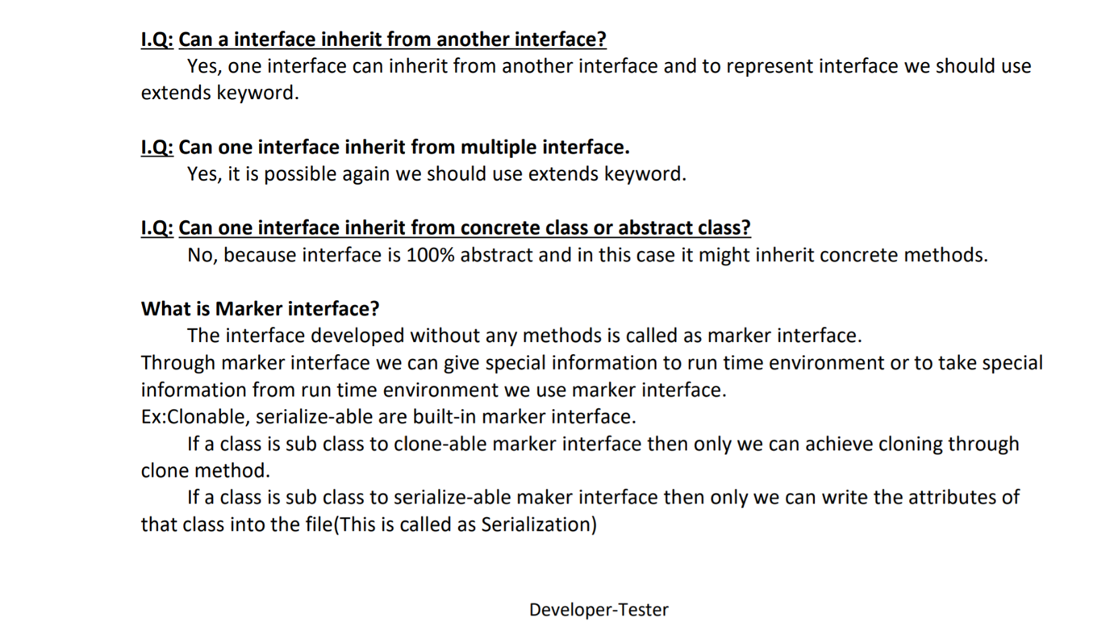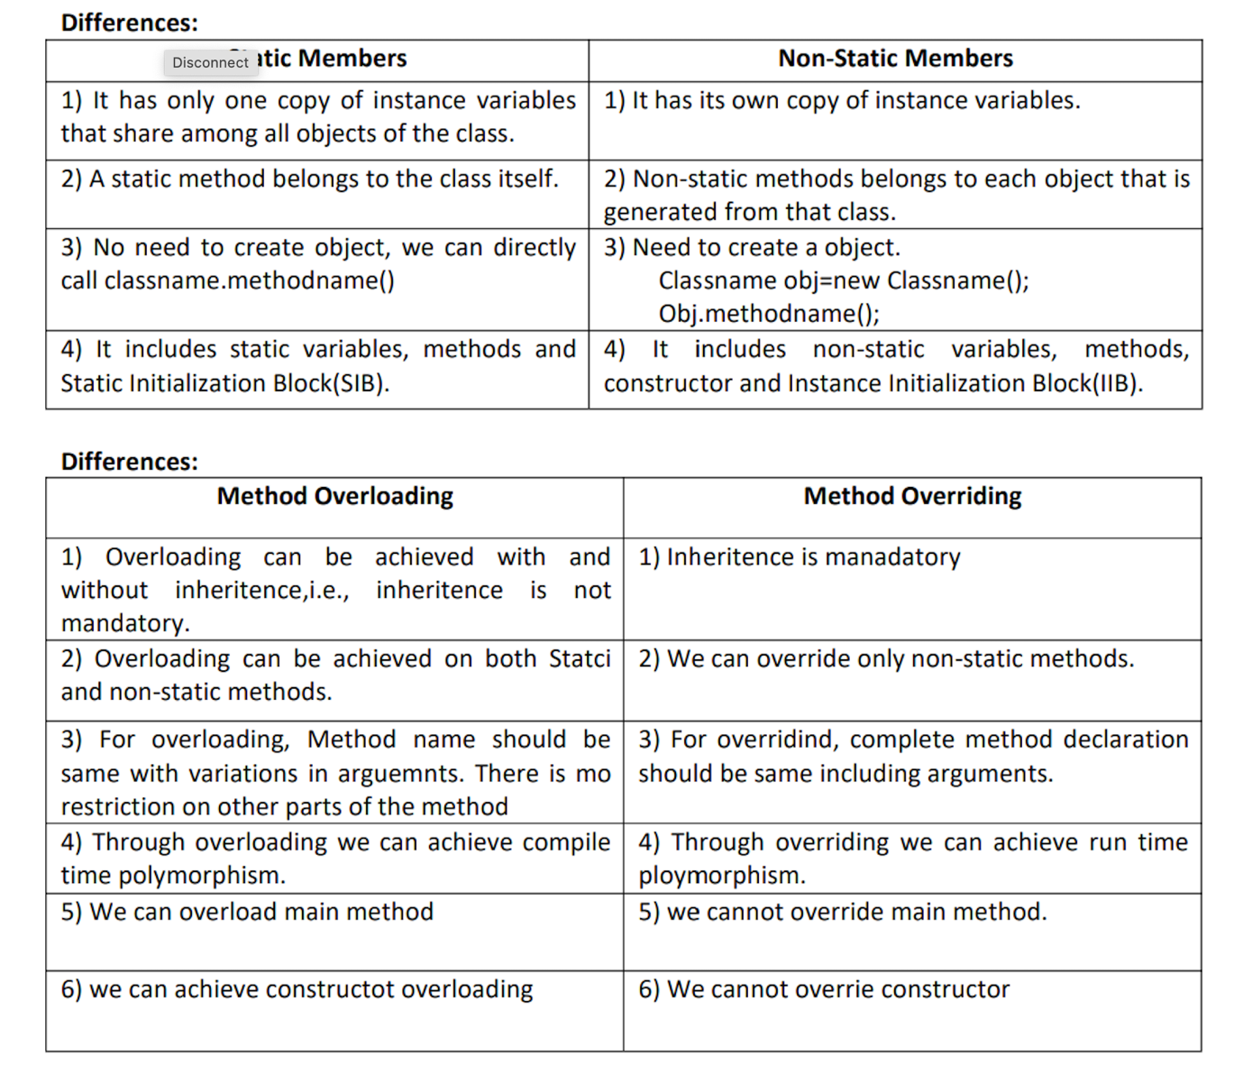

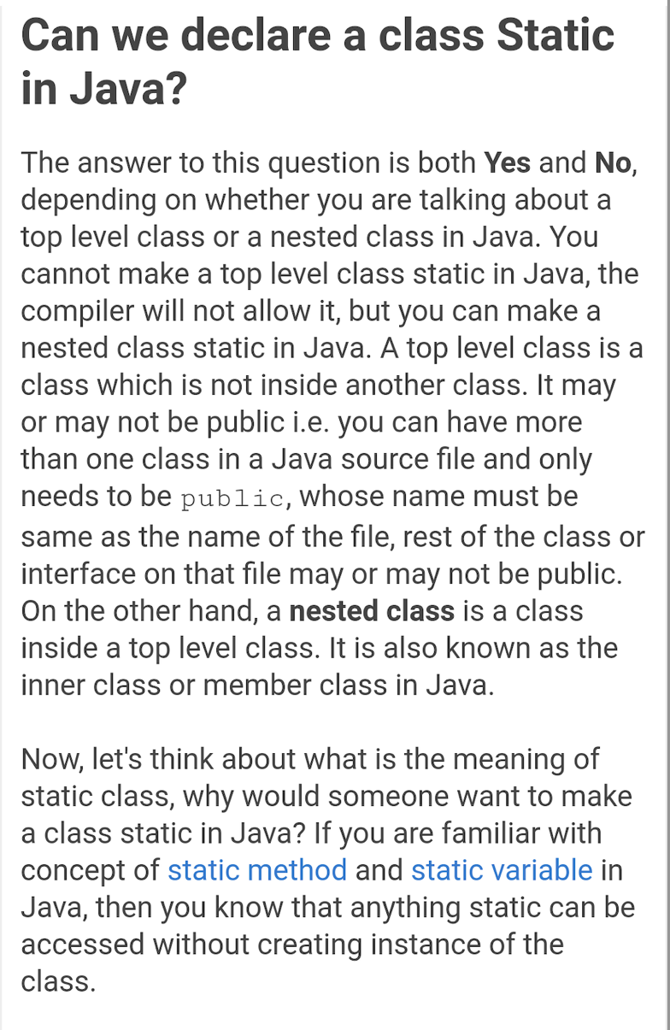

**Array**:

* Array is fixed in size : Not growable in nature
* Only store Homogeneous data, although we can use Object array to store different data.
* No underline data structure readymade methods available (like for sorting and all)

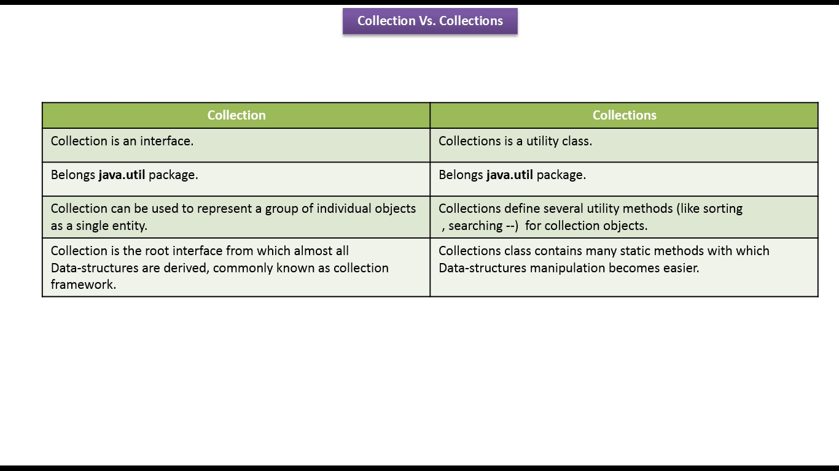

**Collection**:

* Group of element as a single entity.
* It has multiple method (ex. add, addAll, remove, removeAll)
* It is a top most interface, which is implemented by List, Set and Queue interfaces.

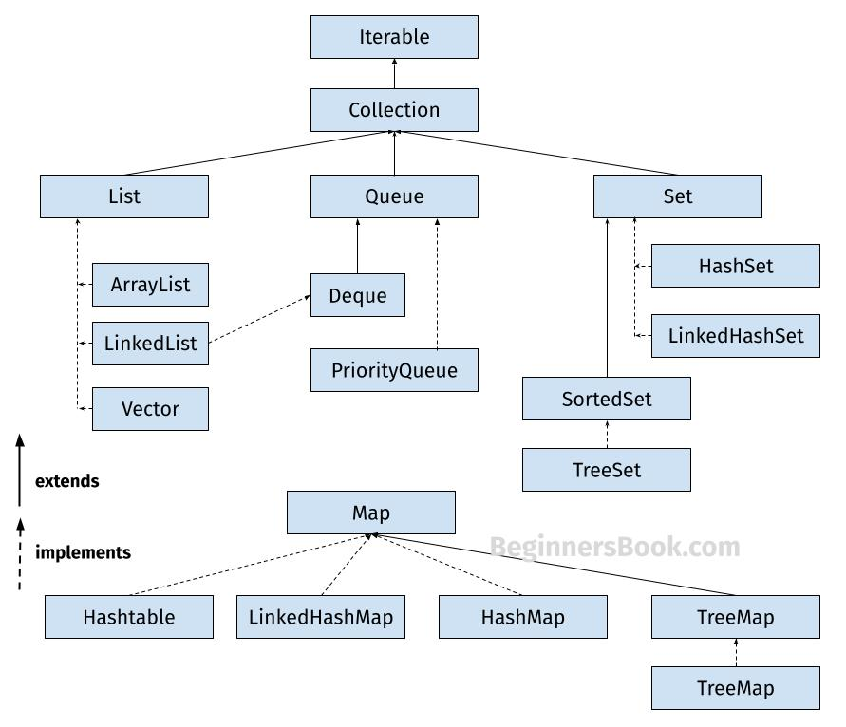

**List**:

* List is an interface which extends Collection interface
* List have its own method + Collection interface method
* List is growable in nature (we can add/delete elements)
* Can contain Homogeneous + Heterogeneous data
* Can contain duplicate values
* Insertion order maintained.

**Arraylist** and **Linkedlist** both implement List interface

* When we want more retrieval operation go for : Arraylist
* When we want more insertion & deletion operation go for : Linkedlist , in this no shifting of element required, will just add new Node or remove Node

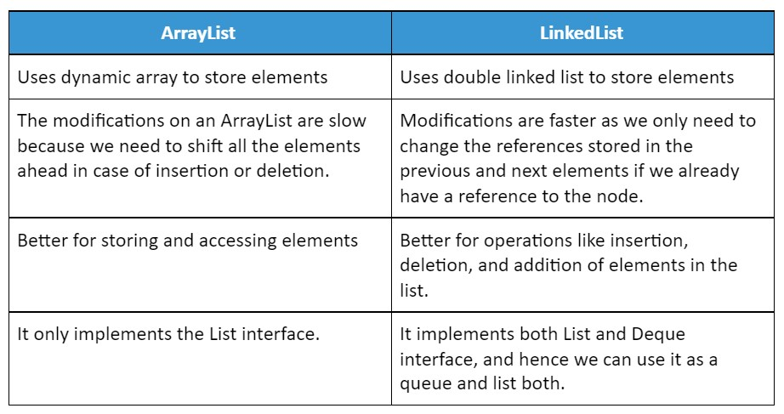

In summary, ArrayList is best for situations where fast access to elements by index is important, while LinkedList is best for situations where frequent insertions and deletions at any position are required

In list default storing capacity is =10

And let suppose we wants to add 1 more element so new list will get created and all element will store in new list(including all 10 and 11th etc) and old list will go for garbage collection.

**Set:**

* Set is child interface of Collection interface
* Insertion order not maintain, means unordered collection
* Duplicate values not allowed
* Internally use Hashcode concept for insertion
* Search operation is very fast : Hashset
* Default capacity is = 16
* When we add new value, so once it reached 75% (load factor) it will create new set and copy old values +new value in new capacity and old will go for garbage collection.
* Load factor is very important in Hashset
* **Hashset** : insertion order not maintain
* **Linkedhashset** : insertion order maintain

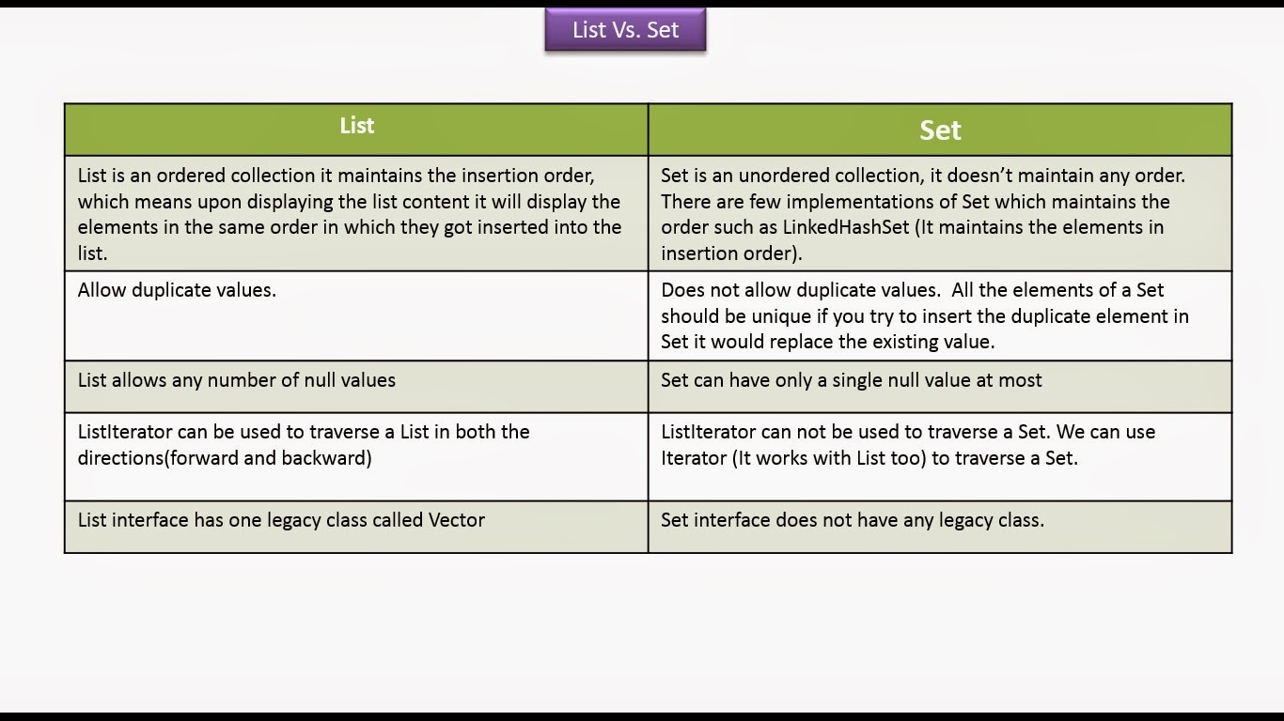

**Map:** Separate interface to store key & value pair

Some methods in map

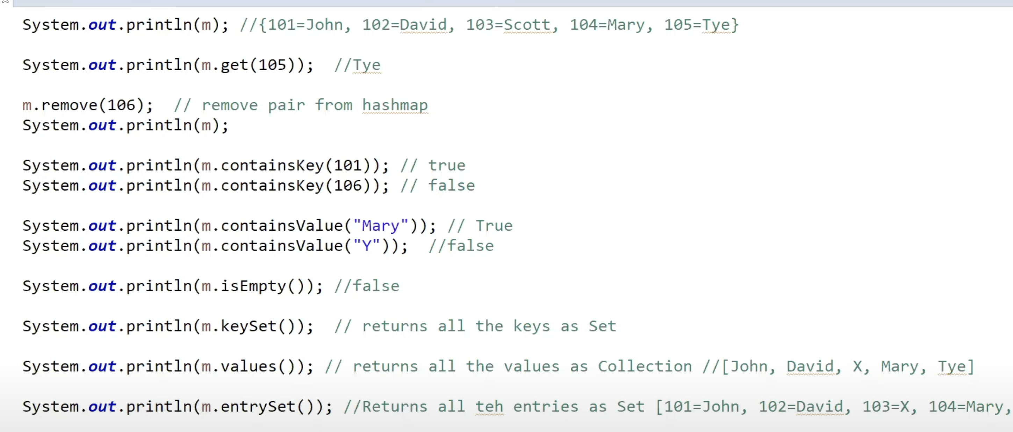

**Hashmap & Hashtable:**

Similarity:

* Both store as key value pair
* Underline data structure is hashtable.

Differences:

